| **STUDENT PORTFOLIO** | |
| --- | --- |
|  | **Name : Hasini Sai GA**  **Register Number:RA2311056010027**  **Mail ID:hg4335@srmist.edu.in**  **Department: DATA SCIENCE AND BUSINESS SYSTEMS**  **Semester: 3** |
| **Subject Title: 21CSC201J Data Structures and Algorithm**  **Handled By : Dr. Rajkumar K.** | |
| **ELAB Completion Status Completed 4-5 questions from all the topics** | |
|  | |
| **Lab Experiment Completion Status  All the 12 experiments were solved, run and executed successfully and took the completed sign from Faculty.** | |
| **REAL WORLD APPLICATION IN DSA PPT VR/SIMULATION DEMO**  **ONLINE VOTING SYSTEM USING HASING AND QUEUE** | |
|  | |
| **Any other**  **(Write if you registered or practise apart from Hackerrank, Leetcode, Github.etc**  **Eg: Certification Programs related to DSA)**    **Hackerrank and CodeChef** | |

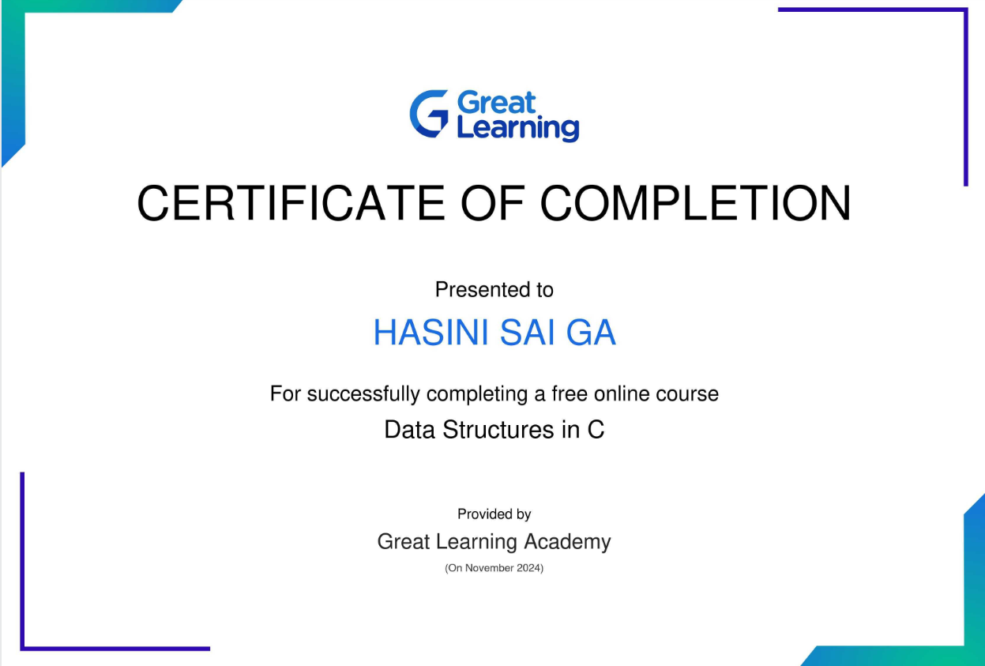

HASINI SAI GA

Signature

